Routing in React:
- use BrowserRouter in app.js
<BrowserRouter>
<Routes>
<Route path="/" element={
<ProtectedRoute> {/* Protect the home component, means only logged in user navigate to home page.*/ }
<Home />
</ProtectedRoute>}>
</Route>
<Route path="/login" element={<Login />}>
</Route>
<Route path="/signup" element={<Signup />}>
</Route>
</Routes>
</BrowserRouter>

- and useNavigate from react-router-dom hook to navigate.
const navigate=useNavigate();
useEffect(()=>{
if(localStorage.getItem('token')){
//get the current user details
}else{
navigate('/login')
}
})

Redux: State management in react
- npm install redux react-redux @reduxjs/toolkit
- steps 1:
  - create state with name suppose loader, initial value and in reducer, action that state want to perform and update the state value.
    - In example: loaderSlice() is function which contain
      - name:loader is a state.
      - Initial value is false
      - reducer: perform action so the value of state is changed.(same as let[user, setuser]=useState(false))
        - here user same as loader name, setuser is reducer.

  - Export const{showLoader,hideLoader}=loaderSlice.actions:
    - which is in reducer action
    - loaderSlice.action ie return reducer.
  - Also export loaderSlice.reducer:
- SO, instead of using loader in each file , We can user this loader state globally.
- Step 2:
  - create store.js
  - import configureStore from redux toolkit.
  - Import loaderReducer from loaderSlice(step 1 created state.)
    - so by default loaderSlice.reducer assign to loaderreducer.
  - Create store using configureStore:
    - reducer:{ loaderReducer}
      - in ES6 if propery name same as value then we can wwrite like this.
      - ES5:reducer:{ loaderReducer:loaderReducer}
  - So Inside store present all state which can be use globally in our react application.

- Step 3:
  - Provide store to the application.
    - Main file of our app is index.js, this is render in browser.
      - Import store from (step2)
      - import Provider from react-redux
      - user <Provider> instead od react.strictMode.
      - Provide store like= <Provider store={store}>
now we can use loader state anywhere in the application.

https://github.com/ukirdemonika/QuickChat_MERN_Project/commit/fa04784fc0aca0a9e94e967955c7272d3a824ab5

Showing Loadin indicator:

- how to use State?
  - App.js
  - Import loaderReducer from store. Using useSelector(loaderReducer)
  - initially value of loader state is false.
  - && :
    - return last truthy value if all operand are true.
    - Otherwise it returns first falsy value.
  - Login.js
    - show loading-true before seding req. And hide th loading indicator after get res.
      - UseDispatch();
      - using dispatch we can call the actions from the reducers.(state.js)

How to Use useDispatch
- Import useDispatch from react-redux.
- Call useDispatch to get the dispatch function.
- Use dispatch to send actions to the Redux store.

When to Use useSelector
✅ To read data from Redux state.
✅ When the component depends on Redux state to display UI.
✅ When you want automatic re-renders whenever the selected state changes.
❌ If you only need to dispatch actions, use useDispatch instead.
https://github.com/ukirdemonika/QuickChat_MERN_Project/commit/f679cc6007586216200dcd66766b62b448cf25cd
Designing the Home Page:
- using Redux state and create User state ,stored it in store using reducer,use dispatch to update the user state and use updated value of user and set using useSelector() and use in header.js .
(its same as useState() hook in react like to update the value of user using setUser())
- https://github.com/ukirdemonika/QuickChat_MERN_Project/commit/0f09704e775ff1baf8242743654c2da83976b68f

Adding side Bar to the Home Page:
- sidebar contain all users , which are seen by currently logged in user. And want to chat with other users.
- After creating side bar, when user type somethimg , we want to store somewhere so that its use when we search the user.
  - Create state using useState hook.
- Fetch all user from Db using getAlluser api call.
  - This will return all the user except currenlty logged in user.
  - Call this api when we call cuurrent user.
  - If res is success , then we want to create new state in userSlice in redux and set in store.

https://github.com/ukirdemonika/QuickChat_MERN_Project/commit/5e398c57ee763f249975ec4cb20bd981b115cc06

Displaying the searched users:
- if user type name in search box then related to name display all the users under the search box.
- https://github.com/ukirdemonika/QuickChat_MERN_Project/commit/16e60b614b9c18627ceed04b70bc1236f7f49cf5

Display existing chat:
- Display all users chat with current user did.
- In chat collection in mongoose we store user ids that whom is doing chating . (in members array)
- so the logic is:
  - if i want to search with whom the current user doing chats, we have to search the current user ID in member array which is in chat collection in mongoose.’
  - whichever chat docs will return that chats will be between current and other users.
  - Disable the start chat button:
    - if e.g john is current user, now john is already did the chat with merry, and john search merry , that case start chat button will be not showing.
    - Search in the members array if merry id (search user id )present or not.
      - If yes:
        - disable the start chat button.
      - If not:
        - show start chat button.
    - Also display those user in the side bar that john already did some chat.

https://github.com/ukirdemonika/QuickChat_MERN_Project/commit/1d24e7c69d42b0e121de54bf7b01e43eed052fc2

Starting a new chat:

- https://github.com/ukirdemonika/QuickChat_MERN_Project/commit/9f43a25ac1efb60f378f51e07640b442258cf3fa

Displaying the selected chat:
- task:
  - if we click on username then display chat ID first in chat area.
- Solution:steps:
  - 1.create selected_chat variable in userSlice (store).
  - 2. create function whose received selected_user_id.
  - 3. find allChat array contains current_user_id and selected_user_id
  - 4. if step 3 return true then
    - update selectedChat with the given chat variable.(dispatch)
- now also if we searched user and when we click on start_chat button then make that chat as a selected_chat.

https://github.com/ukirdemonika/QuickChat_MERN_Project/commit/3f57def24928dc6f467d468e60102217d873287d

Display selected User Details:
- now in selected_Cht object contains only member array which contain user_id of logged in and selected user.
- Change in backend:
  - in get_all_chat Api instead of returning only user id , it will also return compoete user Object.
  - So we used populate() method. It will use like what do you want to populate.
  - So instead of user id only, in members array, populate() will fetch the user object acc to user id from user collection.
  - Set updated:-1: new messaeg comes that msg will go to top.
- Now in frontend we have to do some changes:
  - instead of chat.members only we have to map and get all user id only.
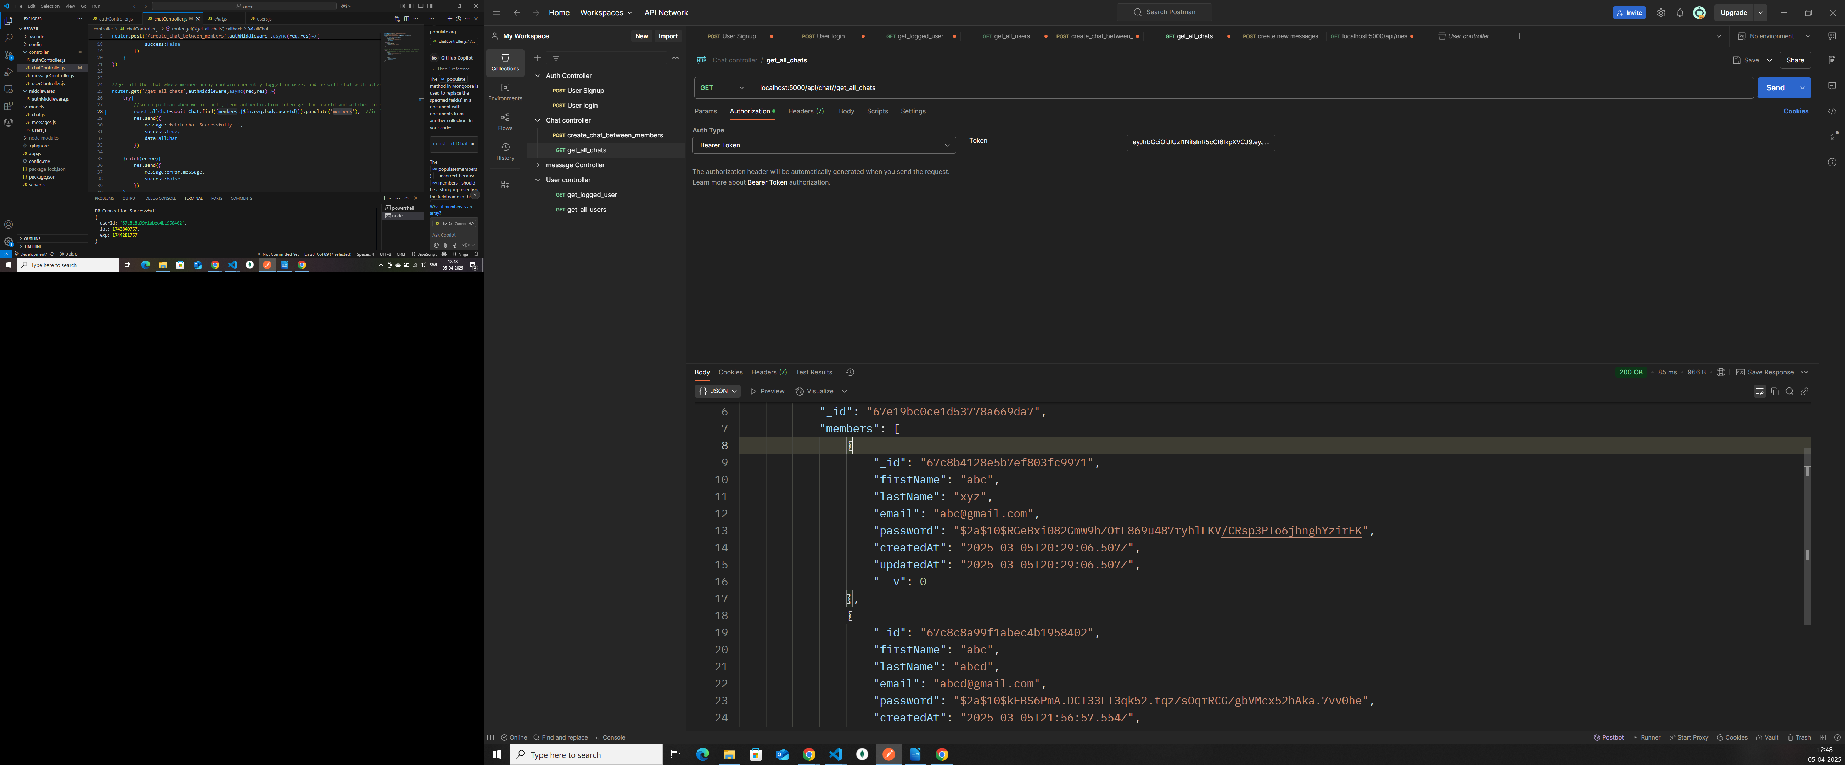

- so now we want ot fetch the second user object(selected user) in chat.js for display.
  - So selectedUser= get from selectedChat variable whose user id doen not match to logged in user id.
  - now highlight selected user.
https://github.com/ukirdemonika/QuickChat_MERN_Project/commit/8234ebf0abe2447aaf80d68c551f3e5185280b02

Sending Messages:
- https://github.com/ukirdemonika/QuickChat_MERN_Project/commit/5c8ffa4719781fd33fda81db8d9a95ab70e456a5

Fetching All Messages:
- https://github.com/ukirdemonika/QuickChat_MERN_Project/commit/4f0ff2103fb9f6c06a6b2b66b218b81a06f34dde

Displaying send and received messages:

